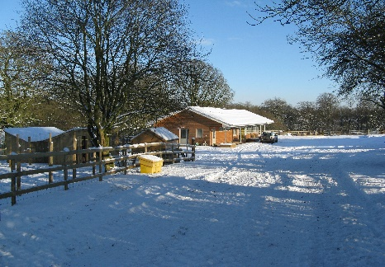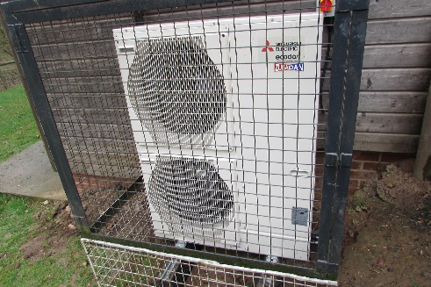

- MPSF classroom building was designed and built in 2008 – 9 to be both economical in its use and sustainable in its structure and maintenance. As such the key features are:
- The building is orientated from due south to north. The south facing side looks over to the working farm area and the cow sheds. When the sun is low down in the winter it still provides warmth at a time when children will be eating their lunches.
- A roof made from reconstituted/ recycled slates. The south facing shallow pitch is suitable for solar heating panels, although these have not been fitted.
- The roof is well insulated and additional insulation has been put around the rainwater header tank.
- Walls made from thermal building blocks that retain heat, externally clad with pre-weathered Siberian larch boarding that will not need treatment. This also matches the style of the dairy farm buildings opposite the classroom.
- External doors and windows are factory impregnated with paint that needs no repainting.
- Rooms are heated by underfloor hot water pipes. A Mitsubishi Electric Ecodan air source heat pump now positioned on the west facing wall provides the hot water for the system. This is programmed to be on between 6.00 and 15.00 hours and 1 hour during the night from September to May. An insulated immersion heater can be switched on in the winter should the outside air temperature be too low to provide sufficient background heat. However even the immersion heater power supply has a timer with a cut-off switch. These features are all designed to reduce electricity consumption.
- We have our own water cycle and therefore do not pay for mains drainage, run-off or sewage charges. Drainpipes direct rainwater from the roof to a 6,500 litre underground storage tank. This water is pumped up to a header tank in the loft and serves the children’s toilets and welly washing tap. It is also piped underground to the sheep and pigs. Mains water is only used for the disabled toilet, for drinking and handwashing. If the rainwater runs out then the header tank will automatically fill up with mains water.
- Water discharged from the toilets travels down to the reed beds lower down in the sheep paddock, through a second bed and is then piped into the stream below. We have a discharge licence from the Environment Agency to operate this system and have to be careful about the products that are used in the toilets and for cleaning.
- Initially all light switches, apart from in the classroom, were triggered by movement. However this proved too impractical in many rooms e.g. the adults’ toilet and the office!
- In the corridor it was also impractical as children constantly moved up and down the space. So these have been changed so that only the children’s toilets, entrance hall and welly wash area are triggered by movement.
- Fluorescent lights in the entrance hall have recently been replaced by more economical, long life led light strips. Gradually all the strip lights will be replaced by led lights.

Amended March 2019

