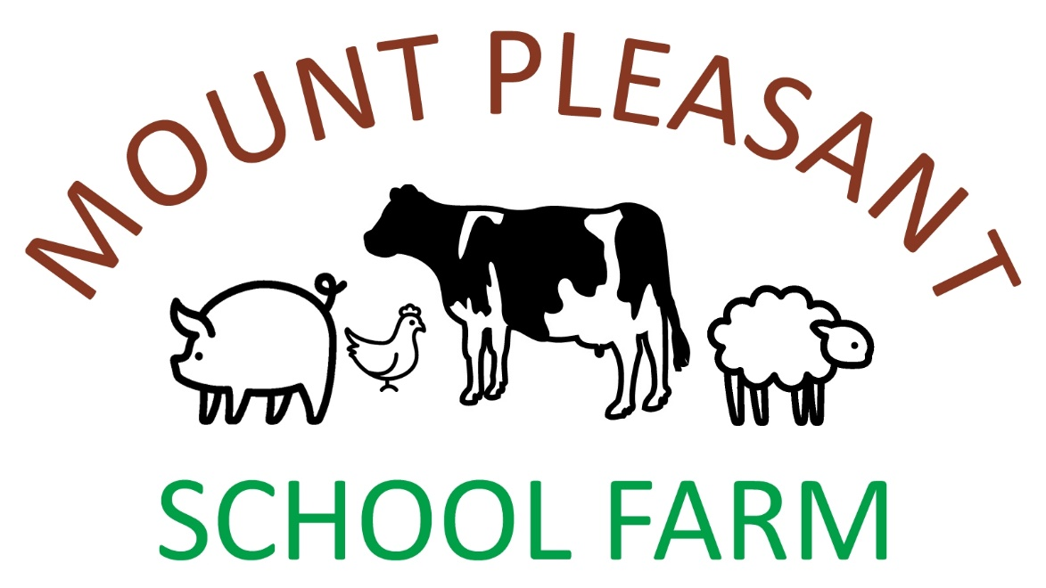

**Icknield Street, Forhill, Kings Norton, Birmingham B38 0EH**

**Tel: 01564 823923 OS Ref: SP056** **751**

**3 words: freed.roof.fame**

**Emergency Procedure**

**If the Farm Teacher is unable to deal with the emergency:**

* First Aid Kit situated in kitchen
* NHS Direct for medical advice **0845 4647**
* Nearest A & E is Alexandra Hospital, Woodrow Drive Redditch B98 7UB
* **Dial 999** and give details of emergency and location
* Contact your school and initiate school procedure
* If incident involves the farm animals or buildings: contact the farmers, Peter & Emma Charles:

Peter & Emma Charles’ farmhouse **01564 822277**

Peter Charles’ mobile **07890 079937**